#### Dimensions (mm)

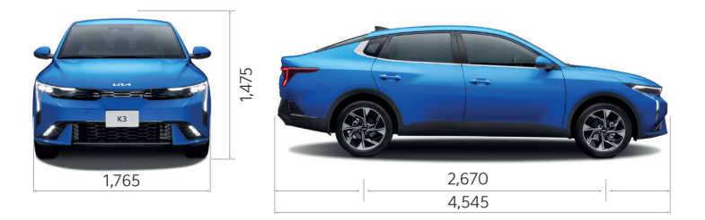

**1.6L MPI**

(123 PS @ 6300 RPM)

**Advanced Driving Assistance Systems**

**6 Airbags**

(2 Front, 2 Side & Curtains)

**Dual-Zone Air Condition**

**Wireless Charger**

**5 Years Warranty**

#### Exterior

* Electric folding mirrors
* Side mirrors with electric adjustment
* Front heated side mirrors
* LED front fog lamps
* LED front lamps
* Rear combination lamp in LED
* Auto headlight control
* Cornering lights
* Side repeater mirror
* LED daytime running lights
* Exterior handles in body color
* LED HMSL

**Interior**

* Dual zone auto A/C with rear vents
* Rear seat alert
* Driver’s seat with manual height adjustment
* 6:4 split back folding for 3 passengers
* Headrests with height adjustment
* Wireless charger
* Seat belts with height adjustment for driver and passenger
* Center console with armrest
* Rear defogger
* Two front USB ports (Type C and Type A) / Two rear USB ports (Type C)
* Driver and passenger vanity mirror
* LED Illuminated vanity mirrors
* Day / night rearview mirror
* LED courtesy light
* Leather-wrapped gear shift knob
* Sports pedals
* Front cup holder
* Front 12V outlet
* Central door lock
* Artificial leather seats with cloth inserts
* Leather-wrapped sport steering wheel

**Safety**

* Dual front airbags + dual side airbags + curtain airbags
* High Beam Assist
* Rear Cross Traffic Collision Avoidance Assist
* Safe Exit Warning
* Hill Start Assist
* Electronic Stability Control
* Front and rear disc brakes
* Anti-lock Braking System
* Immobilizer
* ISOFIX Child Seat Top Tethers & Anchor Fixings
* Tyre Pressure Monitoring System (TPMS)
* Child-safety door locks
* Parking Distance Warning
* Blind Spot Collision Avoidance Assist
* Forward Collision-Avoidance Assist
* Lane Keeping Assist
* Driver Attention Warning
* Lane Following Assist

**Technology**

* 6 speakers
* Bluetooth® with voice recognition
* Rearview monitor with dynamic guides
* 4.2″ Cluster display
* Android Auto™ & Apple Carplay™
* Bluetooth® technology with multi-device connectivity
* Cruise control
* Steering wheel audio controls
* Cruise control with manual speed limit assist
* Smart key + Start button
* Driving modes (Normal, Eco, and Sport)
* Steering wheel-mounted paddle shifters
* 10.25″ multimedia touchscreen
* Ambient interior lighting